First set up a simple scene

This scene should contain a main camera and objects of your choice.

Next add a camera script, by right clicking in assets and adding **C# Script** and rename camera.

Then just click on the camera in the scene and drag the script into the add component at the bottom right of screen.

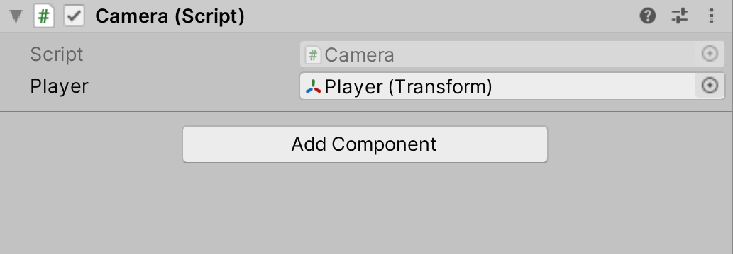

Then open the Camera script

And start the code for the up and down movement

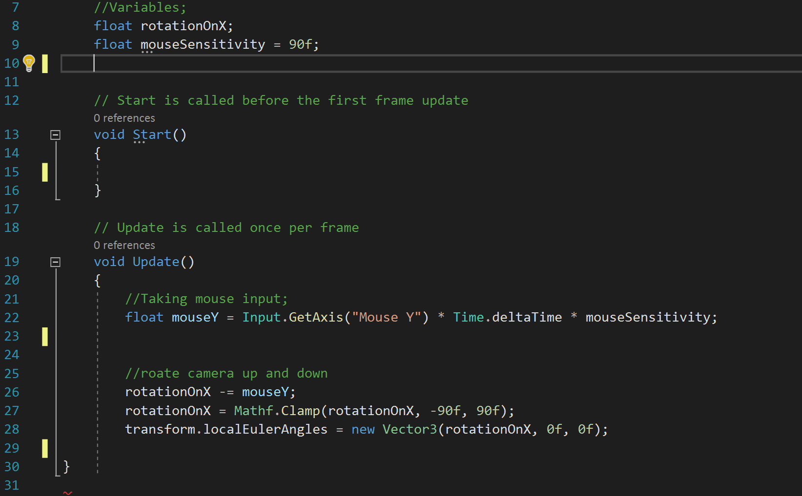

Give that a test by starting the game, which should allow you to look up and down

Now you will need to make a player object with a collider for the camera to connect to, (you can use a block or an existing 3D model later on)

First go to GameObject at the top and select Create Empty, then if want to change the name of the GameObject to Player this will help label everything in the hierarchy. I would centre the Gameobject in the centre of the scene by changing the X and Z position to 0 and change the Y to a 1 so its of the ground.

You will need to turn this into a box collider to do so click add component in the inspector and type in **Box Collider**, then when the outline of a box shows up change the scale of the Y in the box collider to 2 and the X and Z should stay as 1.

Your next step is to drag the main camera in the hierarchy into the player like so.

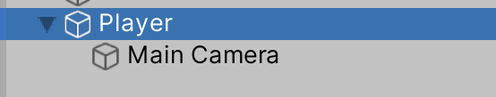

Then if not already change the position to the same as the player Object and put the camera to the top of the box to act as eyes for the camera.

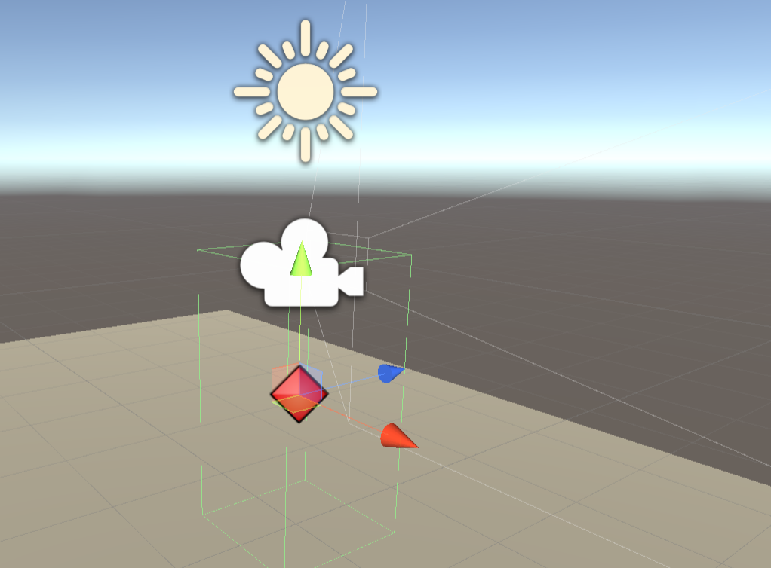

Next you will need to add left and right movement into the script.

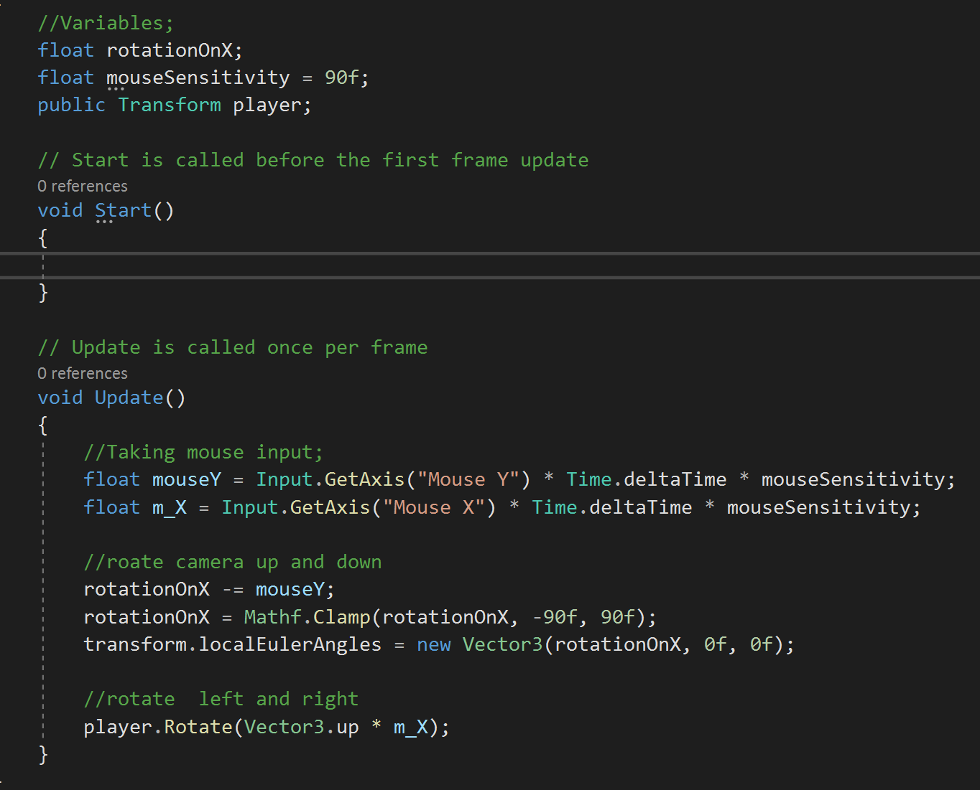

Now the code will work, for you to look left and right as well as up and down.

The last code you will need to add is to hide the cursor in the game this is a small code not really effecting the scene, but it makes it look better.

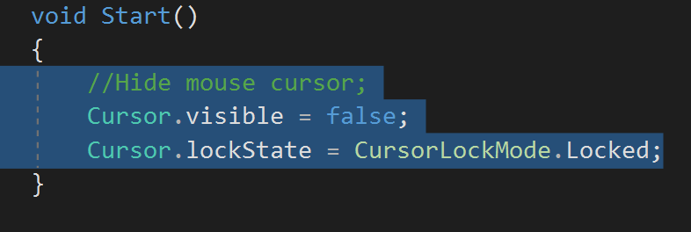

Then you have finished the tutorial of how to make a FPS camera for a game, next you can add in a walk code and follow on from there for a first person game.